Standard Operating Procedure (SOP) #14

Managing Photographic Images

Version 2.01 (March 14, 2022)

Change History

|  |  |  |  |  |  |
| --- | --- | --- | --- | --- | --- |
| New Version # | Revision Date | Author | Changes Made | Reason for Change | Previous Version # |
| 2.0 | 5/24/2021 | Kelly Kozar, Kim Weisenborn, Jacob Gross | Updated folder structure and instructions. Revised section on organizing images, and few other minor updates like SOP references and external links. Added new procedures for managing photos captured with ArcGIS Field Maps® app, utilizing AGOL cloud storage, and photo processing with ArcGIS and R. | To reflect current folder setup and how to process the images. To update outdated SOP references and external links. To better document species identifications and utilize the suite of capabilities available with smart devices, ESRI apps, and AGOL. | 1.0 |
| 2.01 | 3/14/2022 | Kim Weisenborn | Updated content to refer to new PACN I&M SharePoint. Updated figures to reflect change. | PACN data is no longer stored on a networked server (I:\ drive) and is now stored on the PACN SharePoint site. | 2.0 |
|  |  |  |  |  |  |

Only changes in this specific SOP will be logged here. Version numbers increase incrementally by hundredths (e.g., version 1.01, version 1.02) for minor changes. Major revisions should be designated with the next whole number (e.g., version 2.0, 3.0, 4.0). Record the previous version number, date of revision, author of the revision, changes made, and reason for the change along with the new version number.

Purpose

This SOP describes how to download and process ArcGIS Field Maps® photographic images collected by project staff or volunteers while conducting both Focal Terrestrial Plant Communities (FTPC) and Established Invasive Plant Species (EIPS) monitoring.

The standards described herein pertain specifically to all digital photographs related to FTPC and EIPS Monitoring. In this SOP, digital photograph refers to any photo in electronic format regardless of acquisition by scanner or digital camera. Most photos acquired and used by I&M personnel should fit into one of the general categories.

1. *Library Photos*: These photos are final products that have been edited, documented, reviewed, and added to the photo archive in the [Pacific Island Inventory and Monitoring Network (PACN) Monitoring Archive Library](https://doimspp.sharepoint.com/sites/nps-PWR-PACNIM/monitoring_archive)[1] in the [PACN SharePoint (SPO) site](https://doimspp.sharepoint.com/sites/nps-PWR-PACNIM/)[2]. These photos are representative, unique, and instructive and can be used for multiple purposes by a variety of staff.
2. *Data Photos*: Data photos are photos collected as data. Care should be taken to distinguish data photos from incidental or opportunistic photos taken by project staff. Data photos are those taken for at least one of the following reasons, to:

* Document a particular feature or perspective for the purpose of site relocation
* Capture site habitat characteristics and possibly to indicate gross structural changes over time
* Document a species detection or unknown species that is also recorded in the data
* Document crewmembers conducting monitoring (used in reports, etc.)

Data photos may be linked to specific records within the database and are stored in a manner that permits the preservation of those database links. Other photos – e.g., of field crew members at work, or photos showing the morphology or behavior of certain species – may also be retained but are not necessarily linked with database records.

1. *Misc Photos*: Miscellaneous photos are photos taken during monitoring missions but that do not pertain directly to monitoring data. These photos may be useful for efforts and operational reviews. For example, photos taken while camping or traveling, helicopter operations, touring park locations outside of sampling frame, etc.

Image Management Workflow

Effectively managing hundreds of photographic images requires a consistent method for downloading, naming, editing, and documenting. The general process for managing photos proceeds as follows:

1. File structure setup
2. Image acquisition
3. Syncing & Downloading files
4. Process Photos
5. Rename the image files according to convention
6. Review and edit or delete the photos
7. Move into appropriate folders for storage
8. Establish database links
9. Document the photos
10. Final storage

File Structure Setup

Prior to data collection for any given year, project staff will need to set up new folders under the “Images” folder in the [FTPC Monitoring project workspace](https://doimspp.sharepoint.com/sites/nps-PWR-PACNIM/vital_signs/Forms/File%20Count.aspx?id=%2Fsites%2Fnps%2DPWR%2DPACNIM%2Fvital%5Fsigns%2F05%5Ffocal%5Fterr%5Fplant%5Fcommunities&viewid=c0664fba%2D1b29%2D4aef%2D983e%2Ded5dbfffa271) & [EIPS Monitoring project workspace](https://doimspp.sharepoint.com/sites/nps-PWR-PACNIM/vital_signs/Forms/File%20Count.aspx?id=%2Fsites%2Fnps%2DPWR%2DPACNIM%2Fvital%5Fsigns%2F12%5Festablished%5Finvasive%5Fplant%5Fspecies&viewid=c0664fba%2D1b29%2D4aef%2D983e%2Ded5dbfffa271) in SharePoint. Folder structures should be set up as follows (Figure SOP 14.1 and 14.2):

Images[FTPC “Images”](https://doimspp.sharepoint.com/sites/nps-PWR-PACNIM/vital_signs/Forms/File%20Count.aspx?id=%2Fsites%2Fnps%2DPWR%2DPACNIM%2Fvital%5Fsigns%2F05%5Ffocal%5Fterr%5Fplant%5Fcommunities%2FImages&viewid=c0664fba%2D1b29%2D4aef%2D983e%2Ded5dbfffa271) -or- [EIPS “Images”](https://doimspp.sharepoint.com/sites/nps-PWR-PACNIM/vital_signs/Forms/File%20Count.aspx?id=%2Fsites%2Fnps%2DPWR%2DPACNIM%2Fvital%5Fsigns%2F12%5Festablished%5Finvasive%5Fplant%5Fspecies%2FImages&viewid=c0664fba%2D1b29%2D4aef%2D983e%2Ded5dbfffa271)

[Year] The appropriate year (e.g., 2021, 2022, etc.)

_attributes Attributes of the photo that are populated in the field when the photo is taken.

[PARK] Arrange files by 4-letter park code (e.g., HAVO, HALE, etc.)

Data Organized and watermarked plot photos arranged by sampling location and date.

Misc Non-ArcGIS Field Maps® photos that may be pertinent to the monitoring season.

Originals The most up-to-date copy of the AGOL file geodatabase (photos and attributes).

Plant_photos Geodatabase containing all plant photos for that year and park.

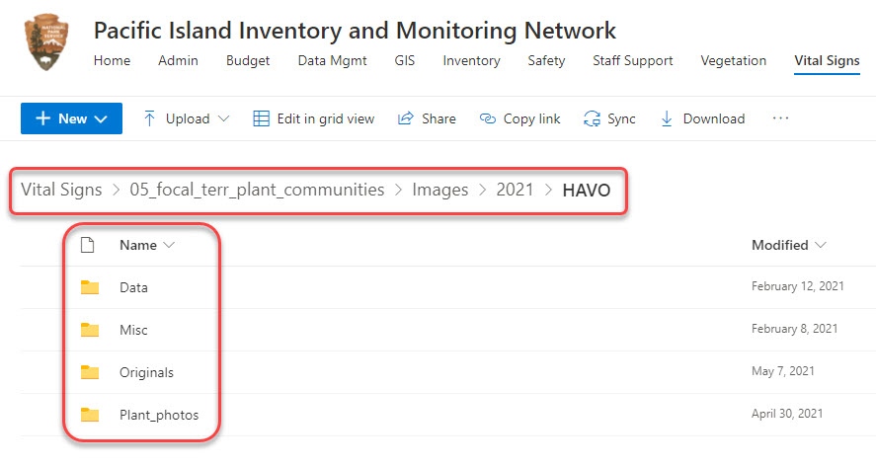

**Figure SOP 14.1.** Example of FTPC Images subfolder structure for a particular year and park in SharePoint.

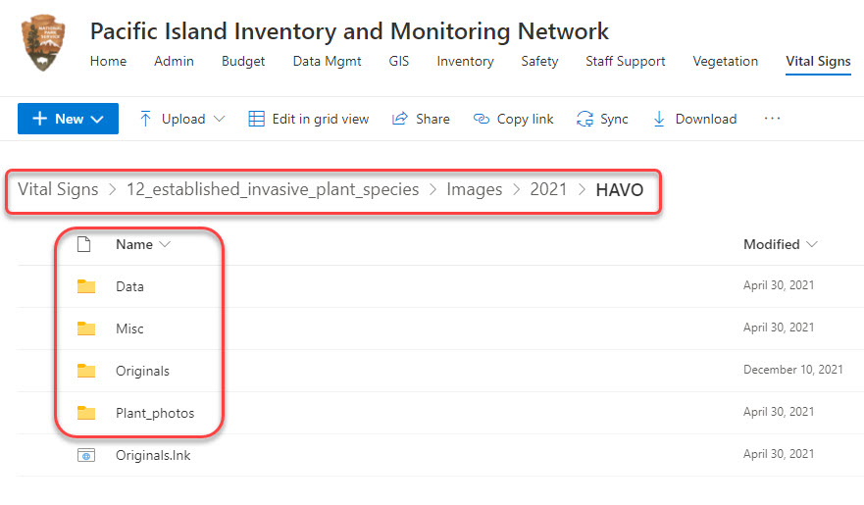

**Figure SOP 14.2.** Example of EIPS Images subfolder structure for a particular year and park in SharePoint.

This folder structure permits data images to be stored and managed separately from miscellaneous images collected during the project. It also provides separate space for storage of originals. For additional information about the project workspace, refer to [SOP #12 Workspace Setup and Project Records Management](https://doimspp.sharepoint.com/sites/nps-PWR-PACNIM/vital_signs/Forms/File%20Count.aspx?id=%2Fsites%2Fnps%2DPWR%2DPACNIM%2Fvital%5Fsigns%2F12%5Festablished%5Finvasive%5Fplant%5Fspecies%2FDocuments%2FProtocol%2FSOPs&viewid=c0664fba%2D1b29%2D4aef%2D983e%2Ded5dbfffa271).

Image Acquisition

FTPC and EIPS photos will be taken using the ESRI ArcGIS Field Maps® App. For steps on collecting ArcGIS Field Maps® photos see [SOP #8 Using Field Maps for ArcGIS](https://doimspp.sharepoint.com/sites/nps-PWR-PACNIM/vital_signs/Forms/File%20Count.aspx?id=%2Fsites%2Fnps%2DPWR%2DPACNIM%2Fvital%5Fsigns%2F12%5Festablished%5Finvasive%5Fplant%5Fspecies%2FDocuments%2FProtocol%2FSOPs&viewid=c0664fba%2D1b29%2D4aef%2D983e%2Ded5dbfffa271).

Three specific ArcGIS Online (AGOL) layers are used to distinguish the three types of vegetation monitoring photos collected in the field, which will be described in more throughout later sections of this SOP:

1. *FTPC Point Photos*: FTPC point photos are images that capture site habitat characteristics and gross structural changes in the plant community over time. They are taken at specific locations within a plot and are designed to be repeatable.
2. *EIPS Point Photos*: EIPS photos taken also capture habitat characteristics and gross structural changes and are taken at specific intervals along the invasive plant transects.
3. *FTPC & EIPS Plant Photos*: Photos of plant species with uncertain identification that need further investigation. These are documented with photos so follow-up identification can be conducted or show why identification was uncertain. Alternatively, plant photos can also document confidently identified species and used as a reference or as a learning tool for future crewmembers.

Syncing & Download Images

Syncing

During field collection, ArcGIS Field Maps® photos and corresponding attribute information are stored locally on the mobile device and must be uploaded (synced) to ArcGIS Online once back in a connected environment. See [SOP #8 Using Field Maps for ArcGIS](https://doimspp.sharepoint.com/sites/nps-PWR-PACNIM/vital_signs/Forms/File%20Count.aspx?id=%2Fsites%2Fnps%2DPWR%2DPACNIM%2Fvital%5Fsigns%2F12%5Festablished%5Finvasive%5Fplant%5Fspecies%2FDocuments%2FProtocol%2FSOPs&viewid=c0664fba%2D1b29%2D4aef%2D983e%2Ded5dbfffa271) for steps to complete data synchronization/upload.

Downloading

Biweekly downloads from [AGOL](https://nps.maps.arcgis.com/) to the [PACN SharePoint site](https://doimspp.sharepoint.com/sites/nps-PWR-PACNIM/) should also be performed in order to back-up the images and attributes stored on the AGOL cloud server.

To download images from AGOL using ArcGIS Pro®:

1. Open ArcGIS Pro
2. Make sure within ArcGIS Pro that you are signed into your NPS AGOL account.
3. Add data from the photo layers hosted on the PACN Vegetation Group on AGOL (if you do not have access to this group, contact Lead Veg Tech, Botanist, or the PACN GIS Specialist).

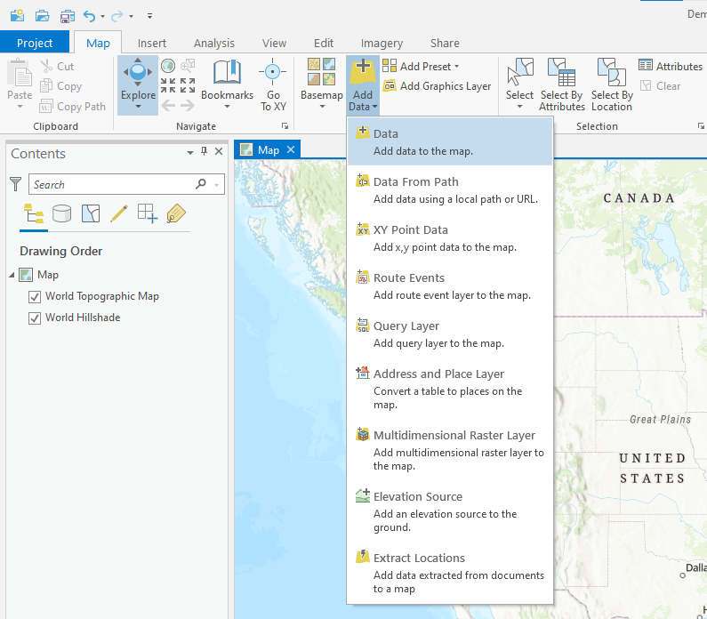

* 1. Navigate to PACN Vegetation Group

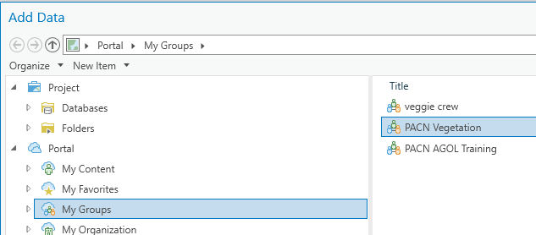

* 1. Select the hosted feature layers with “Photos” and appropriate Year and click OK.

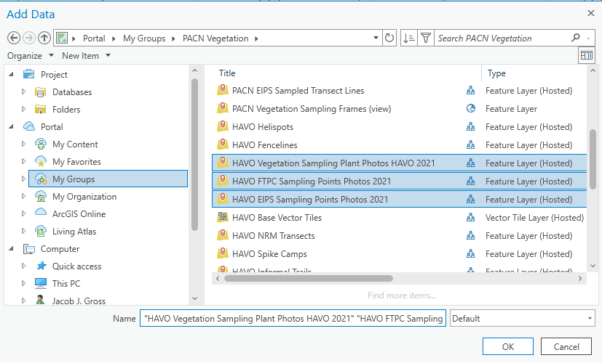

1. Make sure the attribute table is showing all fields:
   1. Right click on feature layer
   2. Select “Attribute Table”
   3. 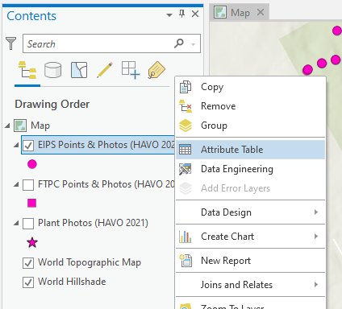
   4. Click on Attribute Menu and select "Show All Fields” (this ensures all attribute fields are exported with the point data).
      1. Note: You will only need to do this once if you save the ArcGIS Pro workspace and later use the same workspace to export the AGOL layers. If “Show all Fields” is light grey in color than all fields are already being displayed.

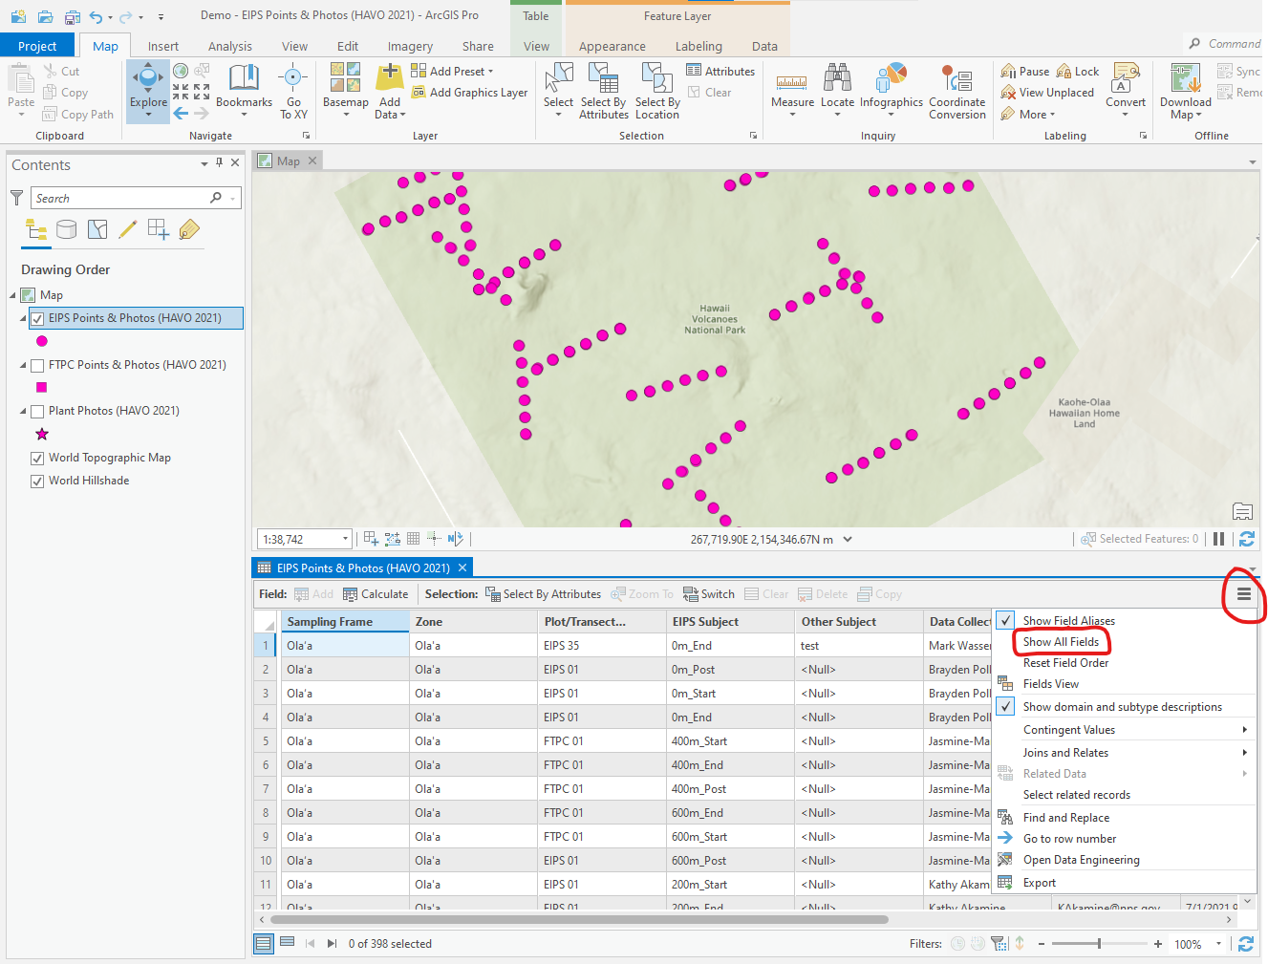

1. Export the feature layer
   1. Prior to exporting, check that the number and locations of points in each layer file are correct. This can be done in the Map viewer in ArcGIS Pro.
   2. IMPORTANT: Before starting export, make sure no features are selected within the layer file you intend to export. If features are selected then only selected features will be exported instead of all features.
      1. To clear any selected features, click on the feature layer you intend to export in the Contents pane, then click the “Clear” button in the Map ribbon. If it is greyed out than no features are selected.

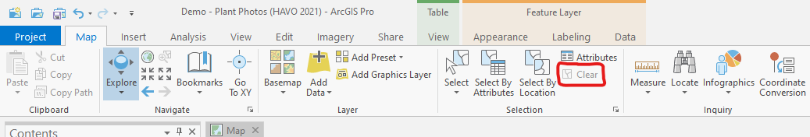

* 1. If no features are selected, then you can start the export by right-clicking on feature layer that you want to export.
     1. Hover over “Data”
     2. Click on “Export Features”

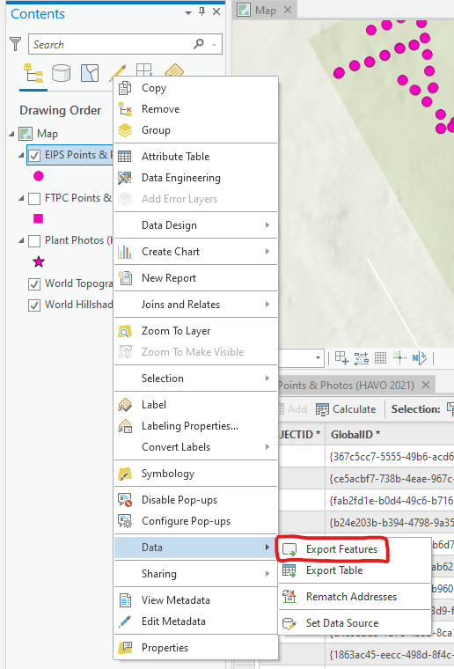

* + 1. Save the feature class to local, a stand-alone file geodatabase. The geodatabase will then be uploaded to the appropriate sharepoint folder.
       1. Click on the folder image next to “Output Location”

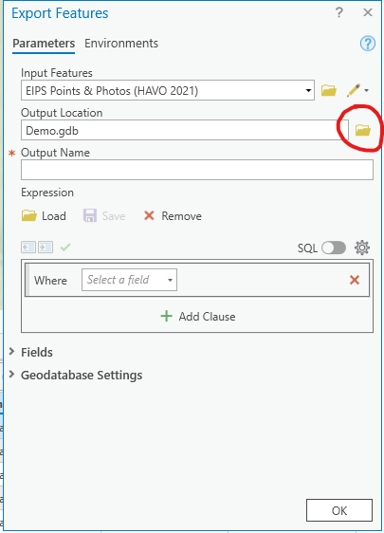

* + - 1. Navigate to an appropriate location on your local computer and create a folder (if needed) and a new geodatabase.
      2. In the example below, a new folder called “Temp_Geodatabase” was created within the Downloads folder on a local computer (it will be deleted after uploading to sharepoint).

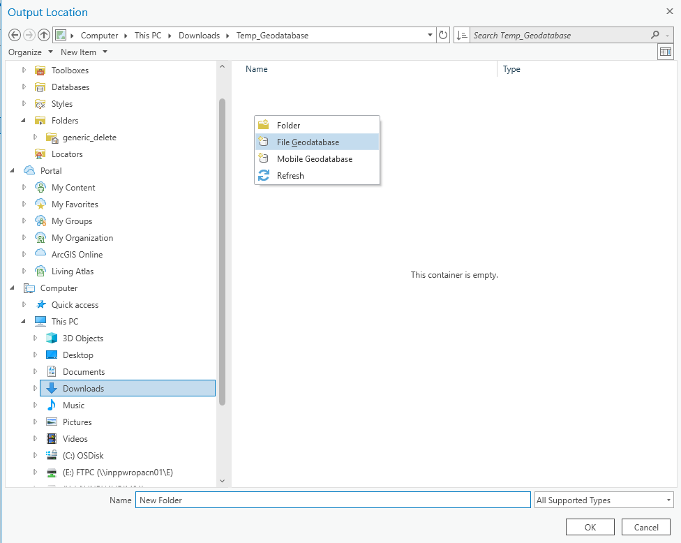

* + - 1. Right click within the empty “Temp_Geodatabase” folder and click on “File Geodatabase.”
      2. Rename the empty file geodatabase using the following naming convention: protocol name or “Plants” if plant photos, write out sampling frame or multiple sampling frames if needed, and date (using year, month, day of the download in the file name):
         1. Examples:

Plants_Olaa_20220318.gdb

FTPC_Olaa_Nahuku_20220318.gdb

EIPS_Kahuku_Maunaloa_20220318.gdb

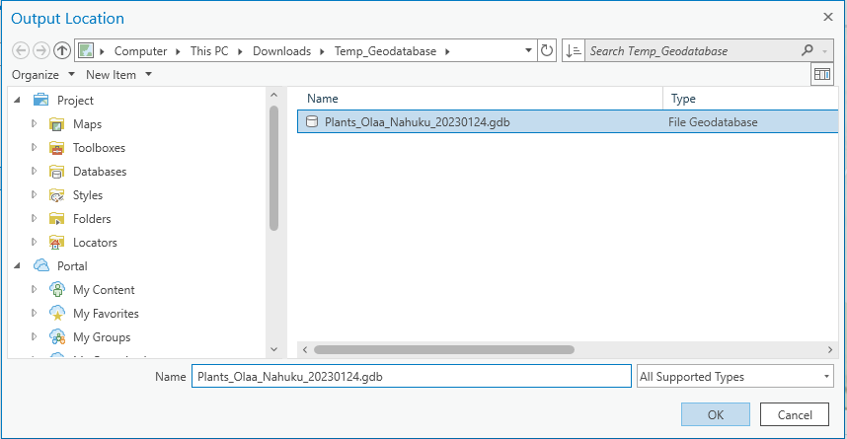

* + - 1. Click on box for “Output Name” and enter the same name used for the geodatabase (without the .gdb).
         1. Examples:

Plants_Olaa_20220318

FTPC_Olaa_Nahuku_20220318

EIPS_Kahuku_Maunaloa_20220318

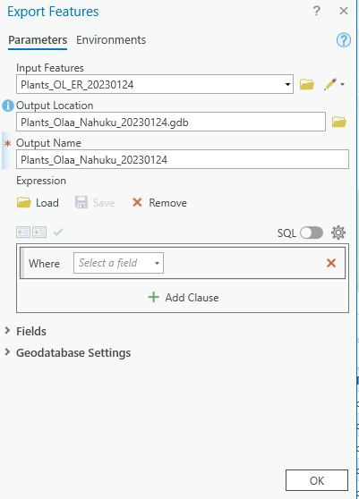

* + - 1. Click “OK” to start the export
    1. The follow progress message will display

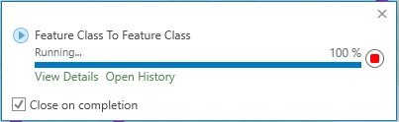

* + - 1. Although it shows 100% within the first few seconds, the export is not complete if “Running...” is still displayed.
      2. To see more information about the status, click on view details. It will show when the export started. The “completed” line will be blank until the process is completed.

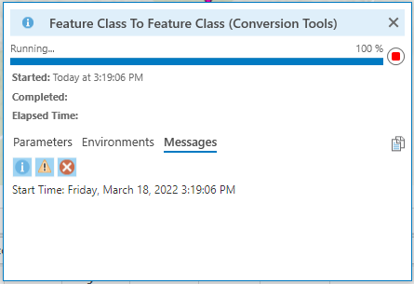

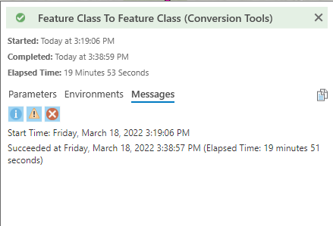

* + - 1. For reference, while teleworking from Hilo and connected to VPN, the FTPC layer file containing 553 points from ~40 plots took 17 minutes to complete. While the Plants layer file with 255 points took 20 minutes to complete (the plants layer file took longer because more photos are taken per point for plants).
      2. Repeat steps for all layer files (i.e. FTPC, EIPS, and Plants).
    1. When all geodatabases are ready, upload the FTPC, EIPS and Plants backups to the same folder on sharepoint:
       1. Vital Signs > 05_focal_terr_plant_communities > Spatial_info > YEAR > PARK > GIS_Data > Data > AGOL_backups
       2. One upload is complete, the local copy can be deleted from your computer. If this is the final copy, and you are processing photos – then do not delete the local copy and proceed with the next section.

Processing ArcGIS Field Maps Images

Use the following steps to process ArcGIS Field Maps® images, add watermarks to photos, organize the photos with the correct folder structure, and name the photos. It is easiest to perform this step when all photos for a sampling frame are complete. Photos can be processed before this time, however, the person performing the processing will then need to track which plots/transects have been completed and which still need processed.

1. Perform a final QA/QC check of the photo data in ArcGIS Pro or AGOL. If using ArcGIS Pro, load all current points into ArcGIS Pro using steps 1-4 in the “Downloading” Section or by opening a previously saved project that is connected to the Plant, EIPS, and FTPC AGOL photo layers.
   1. Check the attribute table for each point to ensure all fields are filled. For Plants layer, check that a final ID has been entered if the original ID was uncertain.
   2. Check that all points are accounted for in FTPC/EIPS layer (e.g. no plots/transects missing, no photo points missing within a plot or transect).
   3. Check spatial location of points to make sure they are reasonable accurate (e.g. no points with obviously inaccurate coordinates.)
2. Save the most recent geodatabase (.gdb) backup (see section above) to the photos originals folder within the appropriate vital signs folder. If new photos/points have been added since the last backup, then create a new backup using the steps outlined in the section above.
3. Copy the most recent geodatabase to the following sharepoint folder(s):
   1. Note that “Plants” gets saved to FTPC vital signs even though the plant photos layer contains both EIPS and FTPC plants.
      1. FTPC = Vital Signs > 05_focal_terr_plant_communities > Images > YEAR > PARK > Originals
      2. Plants = Vital Signs > 05_focal_terr_plant_communities > Images > YEAR > PARK > Originals
      3. EIPS = Vital Signs > 12_established_invasive_plant_species > Images > YEAR > PARK > Originals
4. Download the same geodatabase to your local computer (if not already available).

Process photos in R

If not installed, install Git, R, RStudio, and create a GitHub account on GitHub using following instructions. “Part 1” is copied from this link: [How to use Git with R and RStudio | Reproducible Research Workshop (uzh.ch)](https://www.geo.uzh.ch/microsite/reproducible_research/post/rr-rstudio-git/#:~:text=In%20RStudio%20Select%20File%20%3E%20New,repository%20to%20your%20project%20folder.).

Part 1: Installation and setup

**1. Installation:** To get started you need the following software installed on your computer: [Git](https://git-scm.com/) and if you are new to R, then you also need to install [R](https://www.r-project.org/) and [RStudio](https://www.rstudio.com/). Additionally you will also need a [GitHub](https://github.com/) account.

1. **Git (**[**Download Git**](https://git-scm.com/downloads)**):** Download and install Git, making a note of where on your computer you are install it. Optional Git clients: [*SourceTree*](https://www.sourcetreeapp.com/) or [*GitHub Desktop*](https://desktop.github.com/).
2. **R (**[**Download R**](https://cloud.r-project.org/)**):** Download and Install R (if not already installed).
3. **RStudio (**[**Download RStudio Desktop**](https://www.rstudio.com/products/RStudio/#Desktop)**):** Download and Install RStudio (if not already installed)
4. **GitHub account**: On [GitHub](https://github.com/) create yourself a free GitHub account. If you are new to Git follow the 15 min [*TryGit Tutorial*](https://try.github.io/) to get a quick introduction to Git.

**2. Setup Git in RStudio:** Tell RStudio where to find the Git installation.

1. Open RStudio and go to Tools > Global Options… click on Git/SVN
2. **Check** Enable version control interface for RStudio projects
3. **Set the path to the Git executable** that you just installed. Open a shell, if you don’t know where Git is installed.  
   Windows: type where git and hit enter. The path should be something like: C:/Program Files (x86)/Git/bin/git.exe  
   Linux/OS X: type which git and hit enter. The path should be something like: /usr/bin/git
4. **Restart RStudio**, if it worked out you will find the Git icon on the top toolbar, as shown below.

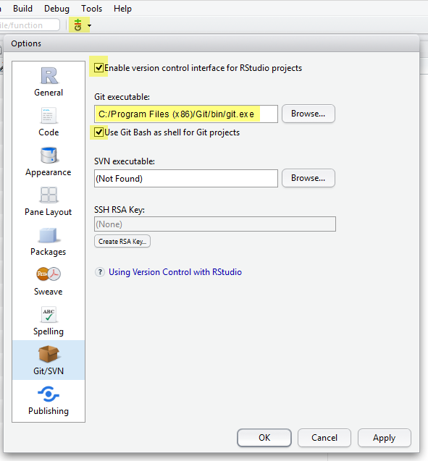

**3. Setup Git**: Configure Git and set your user name and email (the email address you used to register on GitHub). You can directly open the Git prompt from within RStudio. User name and email needs to be set only once. Go to Tools > Shell to open the Git Shell to tell Git your username and GitHub email.

git config --global user.name 'yourGitHubUsername'

git config --global user.email 'name@provider.com'

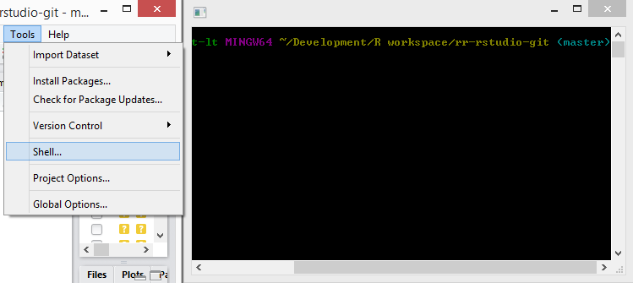

1. Open an R Studio Project
   1. Click on project > New Project

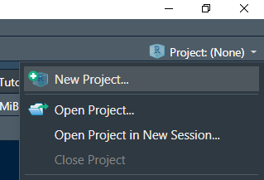

1. Select Version Control

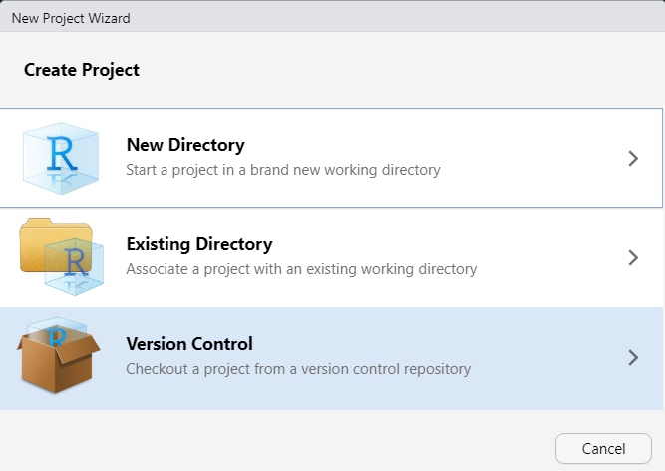

1. Clone a project from a Git repository

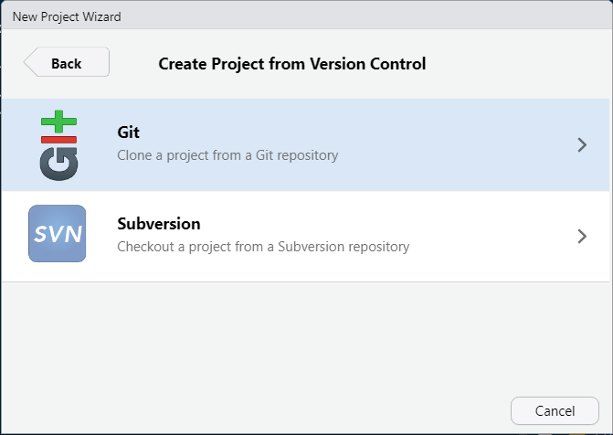

* 1. Paste the following link into Repository URL <https://github.com/jakegross808/pacn-veg-package.git>
  2. Create an appropriate location for project on your computer:
  3. Create Project

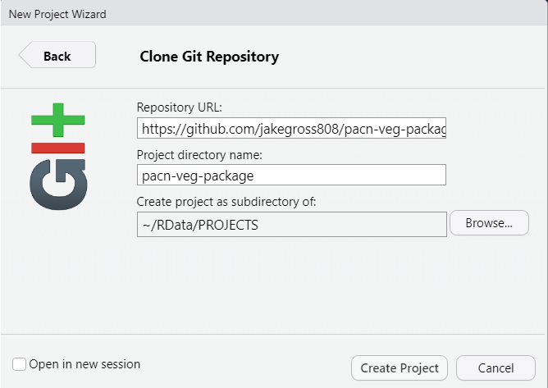

Run R function

1. In the R studio console run the following:

library(pacnvegetation)

* 1. Then run the following (example arguments used):

process_photos(AGOL_Layer = "EIPS",

gdb_name = "EIPS_OL_ER_20220502.gdb",

gdb_location = "C:/Users/JJGross/OneDrive - DOI/Documents/Photo_Processing/FTPC_EIPS_Photo_Processing",

gdb_layer = "EIPS_OL_ER_20220502",

return_table = FALSE))

* 1. Where **AGOL_Layer** can be “EIPS” , “FTPC” , or “Plants”
  2. **gbd_name** is the geodatabase name saved locally
  3. **gdb_location** is the file path to the geodatabase
  4. **gdb_layer** layer is the layer file inside the geodatabase (and should be the same name as the geodatabase minus the “.gdb”
  5. **return_table** if TRUE the table used to label the photos, files, etc. is returned instead of processing the photos. This option can be used to check photo labeling, troubleshoot, etc. If FALSE (default), the photos are processed.
  6. Run the following in R command line to get more help with the function

?process_photos

Photos will be saved inside the folder corresponding to the location where the R studio project was created.

Files will automatically be watermarked, renamed, and copied to the correct folder structure.

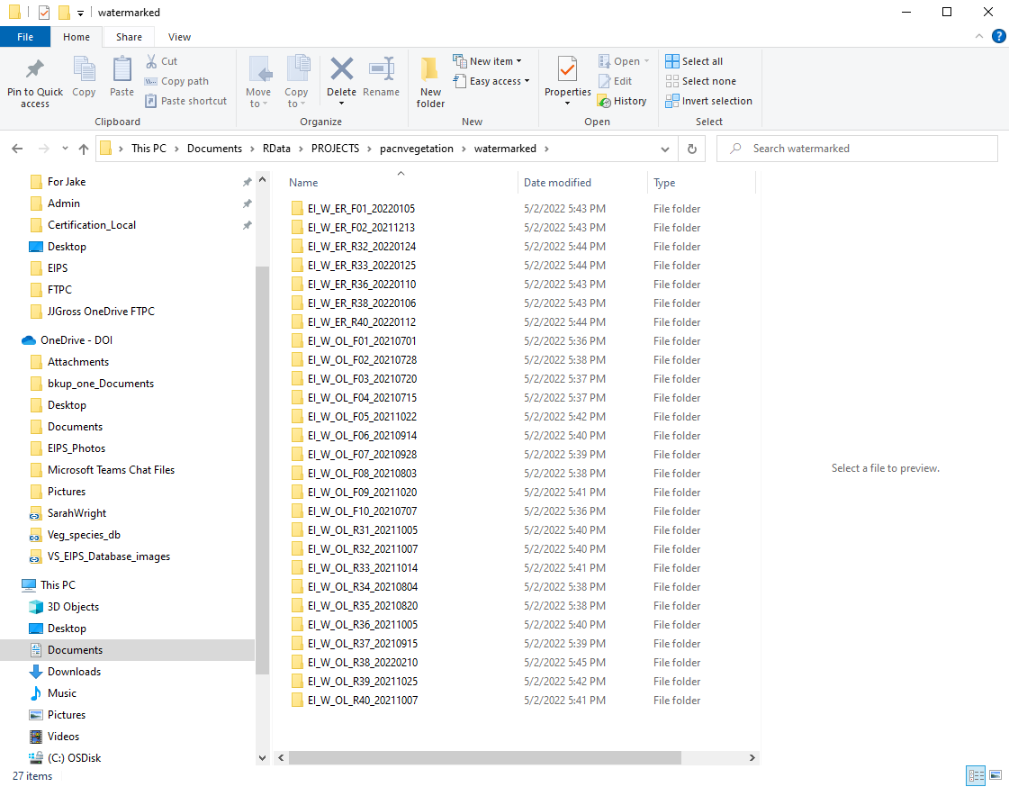

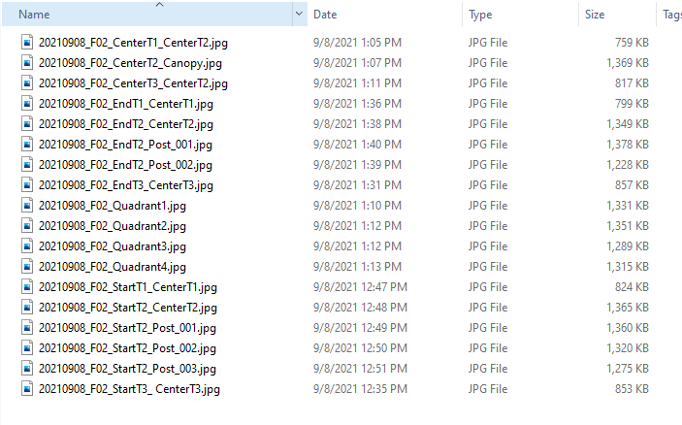

1. Folders with watermarked photos will then need to be copied to the following sharepoint folders:
   1. [https://doimspp.sharepoint.com/:f:/r/sites/nps-PWR-PACNIM/vital_signs/12_established_invasive_plant_species/Images/](https://doimspp.sharepoint.com/:f:/r/sites/nps-PWR-PACNIM/vital_signs/12_established_invasive_plant_species/Images)

NOTE: remember to use appropriate folder structure: “YEAR” > “PARK” > “Data” > “Plant_Community”

* 1. [https://doimspp.sharepoint.com/:f:/r/sites/nps-PWR-PACNIM/vital_signs/12_established_invasive_plant_species/Data/Database/VS_EIPS_Database_images/](https://doimspp.sharepoint.com/:f:/r/sites/nps-PWR-PACNIM/vital_signs/12_established_invasive_plant_species/Data/Database/VS_EIPS_Database_images/2021?csf=1&web=1&e=5Zabei)

NOTE remember to use appropriate folder structure: “YEAR” > “PARK” > “Plant_Community”

Photo Record Datasheet

The Photo Record datasheet (Figure SOP 14.29) is used as a checklist to ensure all required photos are taken in the field. The datasheet can also be used as a backup photo organization method if ArcGIS Field Maps is unavailable. For example, if a standard camera is used, the photo date and time can be recorded for each image to allow future linking of attribute data recorded on the datasheet.

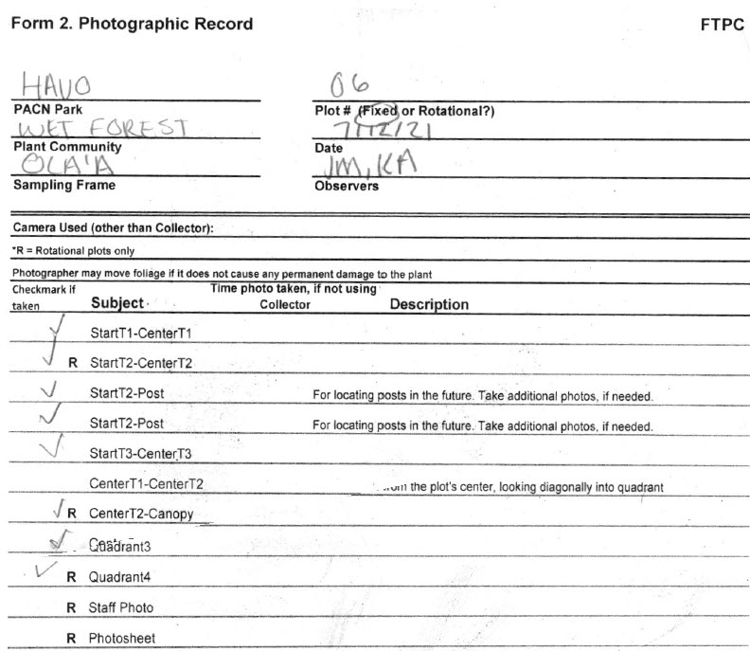

**Figure SOP 14.29**. Example of a Photo Record datasheet.

Folder & File Naming Standards

In all cases, folder & file names should follow these guidelines:

* No spaces or special characters in the folder name
* Use the underscore (“_”) character to separate words in folder names
* Try to limit length of names whenever possible
* Dates within folder names should be formatted as YYYYMMDD for better sorting

Within the “Data” and “Originals” folders, plot folders should be created for each sampling event in which sampling is being conducted for the field season. Individual plot folders should be named to distinguish between protocol, sampling frame, plot type and number, and date that the plot was sampled. If a sampling event is multiple days long, use the first date of the sampling event in the folder naming structure.

Field Maps images will be renamed using the “process_images_YYYYMMDD.R” script and will adhere to the file naming conventions below.

**Folders:** (Table SOP 14.1)

**[Protocol]_[Sampling_Frame]_[Plot_Type+Plot_Number]_[Date]**

FTPC Example: ‘FT_OL_F10_20210517’

EIPS Example: ‘EI_KU_R38_20110604’

| Sampling Frame | Abbreviation |
| --- | --- |
| ʻŌlaʻa | OL |
| Nāhuku /East Rift | ER |
| Mauna Loa | ML |
| Kahuku | KU |
| Kaloko-Honokōhau | KH |
| Kīpahulu District | KD |
| Haleakalā | HA |
| Puʻu Aliʻi | PA |
| Kalawao | KA |
| Hoʻolehua | HO |
| Tutuila | TU |
| Ta‘ū | TA |
| Guam | GU |
| Muchot | MU |

**Table SOP 14.1.** Folder naming convention guide

**File**s: (Table SOP 14.2 and 14.3)

Plot/Transect Photos: [Date]_[Plot_Type+Plot_Number]_[Subject]_[### if multiples]

FTPC Example: 20210517_R52_StartT1_CenterT1_002.jpg

EIPS Example: 20190606_F01_0mEnd.jpg

|  |
| --- |
| FTPC Subject |
| StartT1_CenterT1 |
| StartT2_CenterT2 |
| StartT3_ CenterT3 |
| StartT2_Post |
| CenterT1_CenterT2 |
| CenterT2_Canopy |
| CenterT3_CenterT2 |
| EndT1_CenterT1 |
| EndT2_CenterT2 |
| EndT3_CenterT3 |
| EndT2_Post |
| Quadrant1 |
| Quadrant2 |
| Quadrant3 |
| Quadrant4 |
| Staff_Photo |
| Photo_Record |
| Other |

**Table SOP 14.2.** File naming guide for FTPC photos.

| EIPS Subject |
| --- |
| 0m_End |
| 0m_Start |
| 0m_Post |
| … |
| 1000m_End |
| 1000m_Start |
| 1000m_Post |
| Staff |
| Other |
| Photorec |

**Table SOP 14.3.** File naming guide for EIPS photos.

Plant Photos: [YYYYMMDD]_[XXhXXmXXs]_[Species Code]_[### if multiples]

Example: “20210226_21h01m49s_EREVAL_006.jpg”

Organize Images

Once data images have been edited, reviewed, and renamed, the data images can be copied to the “Data” folder for the correct year and park. Any other miscellaneous images should be moved to the “Misc” folder for the correct year and park (Figure SOP 14.3). Images that are to be linked to the database will need to go into the [FTPC “VS_FTPC_Database_images”](https://doimspp.sharepoint.com/sites/nps-PWR-PACNIM/vital_signs/Forms/File%20Count.aspx?id=%2Fsites%2Fnps%2DPWR%2DPACNIM%2Fvital%5Fsigns%2F05%5Ffocal%5Fterr%5Fplant%5Fcommunities%2FData%2FDatabase%2FVS%5FFTPC%5FDatabase%5Fimages&viewid=c0664fba%2D1b29%2D4aef%2D983e%2Ded5dbfffa271) folder or [EIPS “VS_EIPS_Database_images”](https://doimspp.sharepoint.com/sites/nps-PWR-PACNIM/vital_signs/Forms/File%20Count.aspx?id=%2Fsites%2Fnps%2DPWR%2DPACNIM%2Fvital%5Fsigns%2F12%5Festablished%5Finvasive%5Fplant%5Fspecies%2FData%2FDatabase%2FVS%5FEIPS%5FDatabase%5Fimages&viewid=c0664fba%2D1b29%2D4aef%2D983e%2Ded5dbfffa271) folder for the correct year, park, and community type (Figure SOP 14.30 and 14.31)*.*

Specific procedures for organizing images can be found in the “Uploading Processed Image Files to SharePoint” section in the [SOP Processing Images with GeoJot+ Core® Software](https://doimspp.sharepoint.com/:w:/r/sites/nps-PWR-PACNIM/data_mgmt/sop_documents/SOP_Processing_photos_GeoJot_Core_v2.docx?d=w06c4ba6ec509597992f330dbffcb8918&csf=1&web=1&e=b6gqtq).

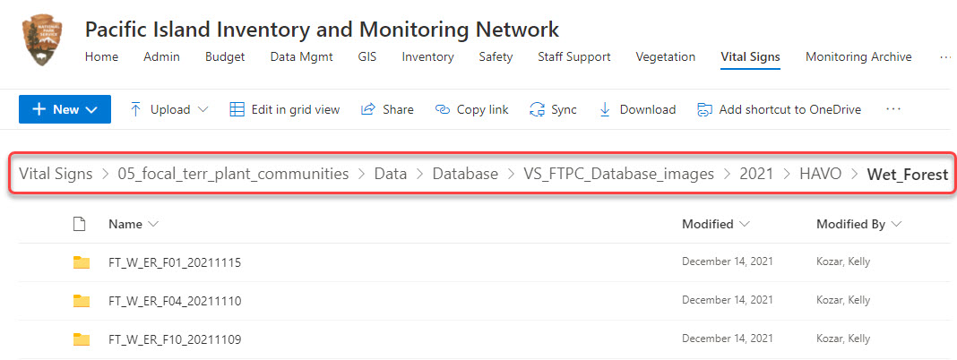

**Figure SOP 14.30.** Example of FTPC database image file location for a particular year, park, and community type.

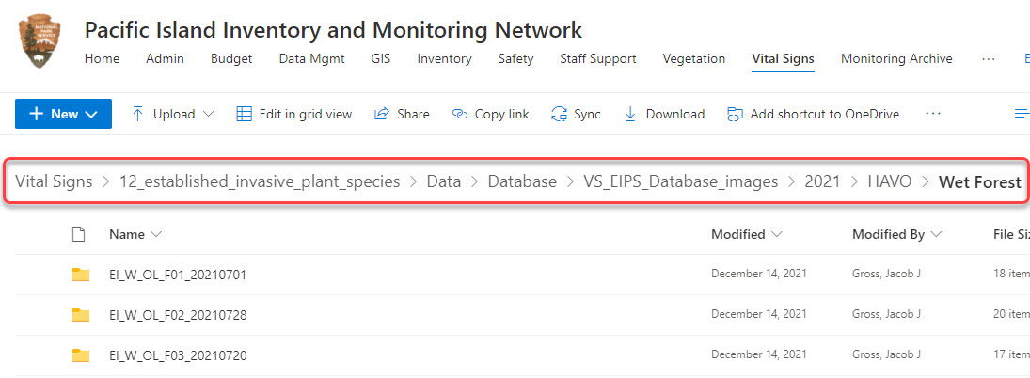

**Figure SOP 14.31.** Example of EIPS database image file location for a particular year, park, and community type.

Photos of interest to a greater audience will be copied to the [PACN Monitoring Archive Library](https://doimspp.sharepoint.com/sites/nps-PWR-PACNIM/monitoring_archive) for [FTPC](https://doimspp.sharepoint.com/sites/nps-PWR-PACNIM/monitoring_archive/Focal%20Terrestrial%20Plants/Forms/File%20Count.aspx) or [EIPS](https://doimspp.sharepoint.com/sites/nps-PWR-PACNIM/monitoring_archive/Established%20Invasives/Forms/File%20Count.aspx) by the PACN Data Manager. Generally, these images are high quality, high resolution, but lower quality images may be included if the subject matter has broad appeal and is special, rare, or unique.

Establish Database Links

Images for the FTPC and EIPS Monitoring protocol can be directly linked to the data in their respective databases. During data entry and processing, the database application will provide the functionality required to establish a link between each database record and the appropriate image file(s). To establish the link, the database prompts the user to indicate the root project workspace directory path, the specific image folder within the project workspace, and the specific file name. This way, the entire workspace may be later moved to a different directory (i.e., the [PACN Monitoring Archive Library](https://doimspp.sharepoint.com/sites/nps-PWR-PACNIM/monitoring_archive) for [FTPC](https://doimspp.sharepoint.com/sites/nps-PWR-PACNIM/monitoring_archive/Focal%20Terrestrial%20Plants/Forms/File%20Count.aspx) & [EIPS](https://doimspp.sharepoint.com/sites/nps-PWR-PACNIM/monitoring_archive/Established%20Invasives/Forms/File%20Count.aspx)) and the links will still be valid after changing only the root path. Refer to the [FTPC SOP #14 Workspace Setup and Project Records Management](https://doimspp.sharepoint.com/sites/nps-PWR-PACNIM/vital_signs/Forms/File%20Count.aspx?id=%2Fsites%2Fnps%2DPWR%2DPACNIM%2Fvital%5Fsigns%2F05%5Ffocal%5Fterr%5Fplant%5Fcommunities%2FDocuments%2FProtocol%2FSOPs&viewid=c0664fba%2D1b29%2D4aef%2D983e%2Ded5dbfffa271) / [EIPS SOP #12 Workspace Setup and Project Records Management](https://doimspp.sharepoint.com/sites/nps-PWR-PACNIM/vital_signs/Forms/File%20Count.aspx?id=%2Fsites%2Fnps%2DPWR%2DPACNIM%2Fvital%5Fsigns%2F12%5Festablished%5Finvasive%5Fplant%5Fspecies%2FDocuments%2FProtocol%2FSOPs&viewid=c0664fba%2D1b29%2D4aef%2D983e%2Ded5dbfffa271), and [FTPC SOP #17 Data Entry and Verification](https://doimspp.sharepoint.com/sites/nps-PWR-PACNIM/vital_signs/Forms/File%20Count.aspx?id=%2Fsites%2Fnps%2DPWR%2DPACNIM%2Fvital%5Fsigns%2F05%5Ffocal%5Fterr%5Fplant%5Fcommunities%2FDocuments%2FProtocol%2FSOPs&viewid=c0664fba%2D1b29%2D4aef%2D983e%2Ded5dbfffa271) / [EIPS SOP #15 Data Entry and Verification](https://doimspp.sharepoint.com/sites/nps-PWR-PACNIM/vital_signs/Forms/File%20Count.aspx?id=%2Fsites%2Fnps%2DPWR%2DPACNIM%2Fvital%5Fsigns%2F12%5Festablished%5Finvasive%5Fplant%5Fspecies%2FDocuments%2FProtocol%2FSOPs&viewid=c0664fba%2D1b29%2D4aef%2D983e%2Ded5dbfffa271) for additional details on setting up the database images structure and establishing these links.

**Note:** It is important that the files keep the same name and location once these database links have been established. Users should not rename or reorganize the directory structure for linked image files without first consulting with the PACN Data Manager.

The procedures for linking images to the FTPC Monitoring Database can be found in [Focal Terrestrial Plant Communities Monitoring Database User Guide](https://doimspp.sharepoint.com/:w:/r/sites/nps-PWR-PACNIM/vital_signs/05_focal_terr_plant_communities/Data/Database/Database_documentation/focal_terr_plants_database_user_guide_sql_v2.docx?d=wa6acc277b351515ba6091c3e794ab694&csf=1&web=1&e=wFXLzW), located in the [FTPC Database Documentation](https://doimspp.sharepoint.com/sites/nps-PWR-PACNIM/vital_signs/Forms/File%20Count.aspx?id=%2Fsites%2Fnps%2DPWR%2DPACNIM%2Fvital%5Fsigns%2F05%5Ffocal%5Fterr%5Fplant%5Fcommunities%2FData%2FDatabase%2FDatabase%5Fdocumentation&viewid=c0664fba%2D1b29%2D4aef%2D983e%2Ded5dbfffa271) in SharePoint*.*

The procedures for linking images to the EIPS Monitoring Database can be found in [Established Invasive Plant Species Monitoring Database User Guide](https://doimspp.sharepoint.com/:w:/r/sites/nps-PWR-PACNIM/vital_signs/12_established_invasive_plant_species/Data/Database/Database_documentation/established_invasives_database_user_guide_v2_01.docx?d=w39417439c4475e5b87000410c6b6c2d2&csf=1&web=1&e=SzaEud), located in the [EIPS Database Documentation](https://doimspp.sharepoint.com/sites/nps-PWR-PACNIM/vital_signs/Forms/File%20Count.aspx?id=%2Fsites%2Fnps%2DPWR%2DPACNIM%2Fvital%5Fsigns%2F12%5Festablished%5Finvasive%5Fplant%5Fspecies%2FData%2FDatabase%2FDatabase%5Fdocumentation&viewid=c0664fba%2D1b29%2D4aef%2D983e%2Ded5dbfffa271) in SharePoint.

Review Images

Delete any poor-quality photos, repeats, blurred or otherwise unnecessary photos. Low quality photos might be retained if the subject is highly unique, or the photo is an irreplaceable data photo.   
Final Storage

At the end of the season, and once the year’s data are certified, data images for the year will be moved to the [PACN Monitoring Archive Library](https://doimspp.sharepoint.com/sites/nps-PWR-PACNIM/monitoring_archive) for [FTPC](https://doimspp.sharepoint.com/sites/nps-PWR-PACNIM/monitoring_archive/Focal%20Terrestrial%20Plants/Forms/File%20Count.aspx) & [EIPS](https://doimspp.sharepoint.com/sites/nps-PWR-PACNIM/monitoring_archive/Established%20Invasives/Forms/File%20Count.aspx) in SharePoint for archival. Before data is certified all data images should be checked for completeness and linked to the database. Since the project images are on the network server, simply inform the PACN Data Manager that the images are ready to be archived. These files will be loaded into the PACN Monitoring Archive Library for FTPC & EIPS in SharePoint, and the database links to data images will be updated accordingly.

**Literature Cited**

National Park Service (NPS). 2006. Digital Photo Metadata Standard, Version 1.0, A Conceptual Model. U.S. Department of Interior, National Park Service. Washington, D.C.

Pacific Island Network (PACN). 2022. [Established Invasive Plant Species Monitoring Database User Guide](https://doimspp.sharepoint.com/:w:/r/sites/nps-PWR-PACNIM/vital_signs/12_established_invasive_plant_species/Data/Database/Database_documentation/established_invasives_database_user_guide_v2_01.docx?d=w39417439c4475e5b87000410c6b6c2d2&csf=1&web=1&e=SzaEud), Version 2.01. Pacific Island Network, National Park Service. Hawaii National Park, HI.

Pacific Island Network (PACN). 2021. [Focal Terrestrial Plant Communities Monitoring Database User Guide](https://doimspp.sharepoint.com/:w:/r/sites/nps-PWR-PACNIM/vital_signs/05_focal_terr_plant_communities/Data/Database/Database_documentation/focal_terr_plants_database_user_guide_sql_v2.docx?d=wa6acc277b351515ba6091c3e794ab694&csf=1&web=1&e=wFXLzW), Version 2.0. Pacific Island Network, National Park Service. Hawaii National Park, HI.

1. PACN Monitoring Archive Library, <https://doimspp.sharepoint.com/sites/nps-PWR-PACNIM/monitoring_archive> (accessed 14 March 2022).
2. PACN SharePoint (SPO) Site, [https://doimspp.sharepoint.com/sites/nps-PWR-PACNIM](https://doimspp.sharepoint.com/sites/nps-PWR-PACNIM/) (accessed 14 March 2022).